PRESS RELEASE
COMMUNICATIONS AND MEDIA TEAM OF THE 43RD ASEAN SUMMIT 2023
No.70/SP/TKM-ASEAN2023/ENG/9/2023

Recommended Delicious Jakarta Street Food

Jakarta, 4 September 2023 – DKI Jakarta the hosts city of the 43rd ASEAN Summit from 5—7 September 2023 offers many tourist destinations. In addition, to the creative economy products like street food snacks are widely available and recommended for the delegates to try.
Taking advantage of the ASEAN Summit momentum, the Indonesian Ministry of Tourism and Creative Economy gives recommendations for typical Jakarta street food snacks that delegates could try during their stay in Jakarta.
Betawi culinary specialties with numerous types of sweets tempt the taste buds, from appetizers to desserts including market snacks can be classified as jajanan pasar or hawkers snacks. It is named street food because they are commonly available in Jakarta’s traditional markets.
Over time, nowadays street food gain prestige and penetrate malls or modern shopping centers.
Minister of Tourism and Creative Economy Sandiaga Salahuddin Uno in his statement in Jakarta, on Monday, 4 September 2023 said Betawi cuisine has authentic and unique flavors that have been passed down from generation to generation.
"I hope that on the sidelines of their agendas, the ASEAN Summit delegates will take the opportunity to taste Betawi culinary specialties so that their working visit to Indonesia, particularly Jakarta, will be more memorable," said Sandiaga.
The following are Jakarta’s typical street food snacks that delegates of the 2023 ASEAN Summit must try:

Kerak Telor
Who doesn't know this delicacy? This legendary Betawi delicacy, which has a savory flavor, a soft texture on the inside, and a crunch on the outside is readily available in Jakarta. It is ideal for serving with hot coffee or tea in the afternoon.
Its savory taste comes from the ingredients used. Duck eggs are mixed with white sticky rice, fried shallot and roasted dried shrimp. Then add the ground spices like red chilies, galangal, ginger, serundeng (coconut flakes), pepper, salt and sugar.
The cooking method is also unique. When the kerak telor dough is half cooked, it is placed in a frying pan and cooked over charcoal.
Selendang Mayang
Selendang mayang is a very popular typical Betawi snack. It is made from rice flour which is added with food coloring (usually green, red and white) combined with syrup, coconut milk and ice. This dish has a sweet, savory, cold and fresh taste. No wonder Selendang Mayang is the perfect dessert.
Bir Pletok
Bir pletok has become an icon of traditional Betawi culture in addition to ondel-ondel. Though the word "beer" is used to name this beverage, it contains no alcohol. In fact, bir pletok is a beverage that can warm and refresh the body, as it is made from a blend of selected spices, such as “secang” wood, cinnamon, ginger, lemongrass, red ginger, turmeric, black pepper, pandan leaves, nutmeg, lime leaves, kembang lawang (Illicium verum), kapulaga (Illicium verum) and cloves. Add sugar and salt to make it more refreshing.
Kue Cincin (ring-shaped pastries)
As the name suggests, this cake has a ring shape and is brown in color because it is made with brown sugar. Betawi people usually present ring cakes at special events such as weddings and circumcision’ ceremonies. It is made of rice flour, roasted coconut, and brown sugar.
Kembang Goyang
Not only Kue Cincin, Kembang Goyang is frequently served at Betawi community celebrations. The name "kembang goyang" derives from its flower-like shape, and its preparations entail shaking the dough until it comes out of the mold.
It is made from simple ingredients, only rice flour is added with salt and sugar, then fried the dough until it is dry and garnish with sesame seeds. This snack has a savory and sweet taste.
Talam Pandan
The traditional Betawi cake Talam pandan has spread throughout Indonesia. Its delectable taste and beautiful appearance make it a favorite of many people.
This cake’s design, which resembles a lotus flower, is distinguished by its two different layers. The bottom layer is typically made from sticky rice dough that is chewy. Meanwhile, the top layer is made of a green dough consisting of rice flour, sugar, coconut milk and pandan leaves.
To make it more beautiful, talam cakes are often decorated with pieces of pandan leaves, coconut flakes or sesame on top.

Putu Mayang
Putu mayang is a traditional Betawi snack made from rice flour and coconut milk. It resembles round noodles. Typically, putu mayang is served with thick liquid brown sugar which imparts its distinct sweetness.

***
For more information, please contact:
Director General of Public Information and Communications of the Ministry of Communications and Informatics – Usman Kansong (0816785320).
Get more information at http://asean2023.id, https://infopublik.id/kategori/asean-2023, and https://indonesia.go.id/kategori/ragam-asean-2023

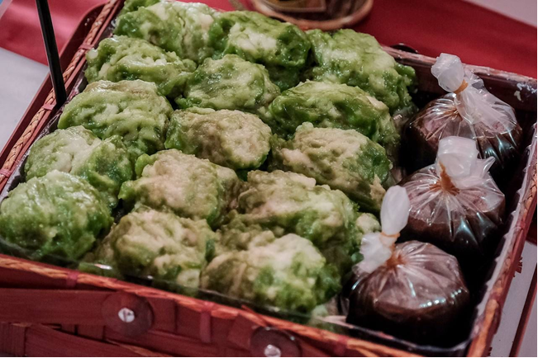
Putu mayang is a traditional Betawi snack made from rice flour and coconut milk. It looks like rounded noodles. Usually, putu mayang is served with thick liquid brown sugar, giving it a distinctive sweet taste that is very savory. (Ministry of Tourism and Creative Economy)
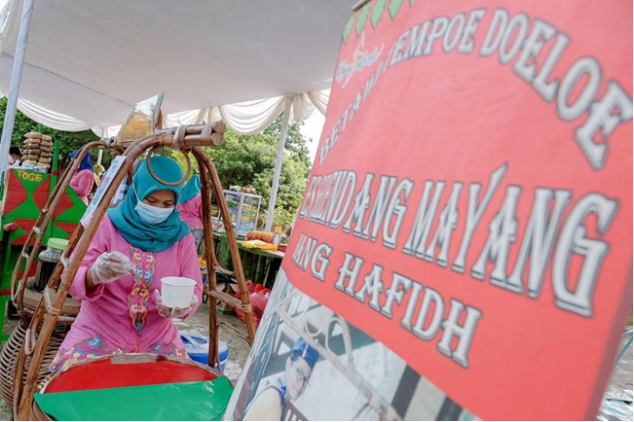

Selendang mayang is a very popular Betawi typical snack. It is made from rice flour added with food coloring (usually green, red and white) combined with syrup, coconut milk and ice. This dish has a sweet, savory, cold and fresh taste. No wonder Kembang Mayang is the perfect dessert. (Ministry of Tourism and Creative Economy)

